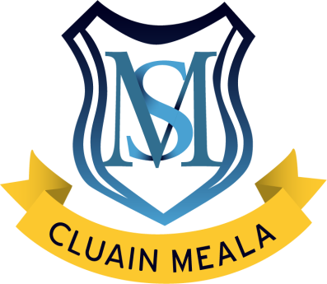
St. Mary’s C.B.S.

Irishtown, Clonmel, Co. Tipperary
Tel: 0526121594 Email: stmaryscbsns@yahoo.ie Roll No: 16728Q

Teacher: Mr. Power Class: 2nd Class

*As part of the Free Schoolbooks Scheme in primary schools, all pupils will be provided with books, workbooks and copybooks in September. All books must be looked after and any lost or damaged books must be replaced by parents.
*Parents are asked to provide their child with:
  - 1x durable pocket folder for homework (with zip)
- 1x A4 plastic folder with button fastening
- 1x A4 Display Folder / 40 Pages
- 1 x scissors, 2 x glue sticks and 30cm ruler labelled with child’s name
- Pencil case with pencils, rubber, topper and 1x red biro
- 1x packet of Crayola Twistables -12 in a packet (for school use only)
- 2 x Whiteboard Markers clearly labelled

*There will be a charge of €40 per pupil (€50 for family) to alleviate the cost of art materials and photocopying.
*Busy Bees – Contact Vanessa on 086 044 4202
*Bus Service – Contact Andy McCoy on 087 625 5442
*Information on school uniforms is available on our website www.stmaryscbsclonmel.scoilnet.ie/uniform
*Half Zip and Skinnies are available from O’ Reilly Sports.
www.oreillysofficial.com/product-category/st-marys-cbs-clonmel/
*Lunches are available to order to the school for your convenience.
www.thelunchbag.ie
*School will reopen on Wednesday 30th August 2023

